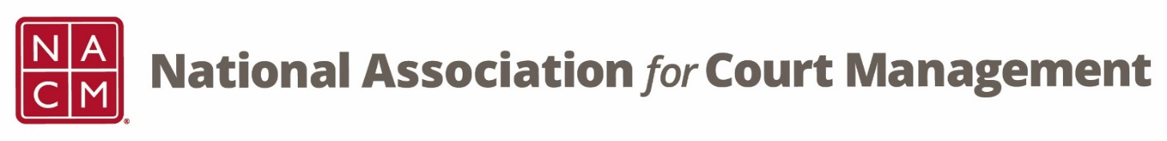

CORE® Committee Meeting
March 22, 3 p.m. ET
Zoom Core® Subcommittee Meeting
Meeting ID: 870 2190 4254
Passcode: 461646

AGENDA:
- Previous Meeting Minutes (attachment)

- CORE Champion
  - Annual Conference
  - Website

- CORE News (Brandon Kimura)

- Curriculum Review
  - CORE In Practice – Janet Cornell
  - Public Relations – Dawn Palermo

- CTC Presentation/Proposal

- NACM Awards
  - Award of Merit
  - Perkins Award
  - Outstanding Early Career Professional Award
  - Enhancing Justice Award

- Call for Nominations Board Candidacy

- Other:

- Next Meeting(s):
  - April 26, 2023
  - May 24, 2023
  - June 28, 2023

