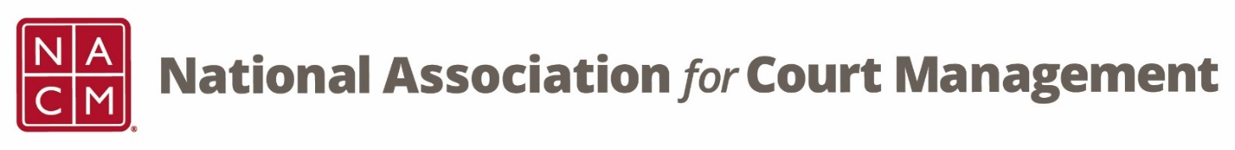

CORE® Committee Meeting
May 24, 3 p.m. ET
Zoom Core® Subcommittee Meeting
Meeting ID: 870 2190 4254
Passcode: 461646

AGENDA:
- Previous Meeting Minutes (attachment)

- CORE Champion Database - Dawn Palermo

- CORE News - Brandon Kimura

- Curriculum Review
  - CORE In Practice – Janet Cornell (attachment)
  - Public Relations – Dawn Palermo (attachment)

- CTC Presentation/Proposal – Roger Rand

- NACM Awards

- Call for Nominations Board Candidacy

- Strategic Priorities

- Other:

- Next Meeting(s):
  - June 28, 2023

