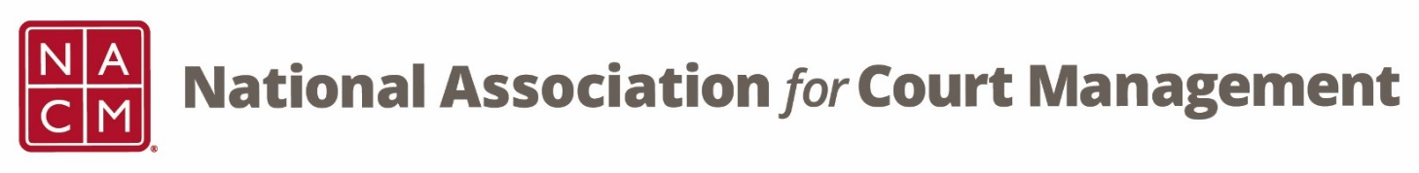

**CORE® Committee Meeting**

June 28, 2023

[Zoom Core® Subcommittee Meeting](https://us06web.zoom.us/j/87021904254?pwd=NjA3SE93REJ5bjYyZExRcEJPeVdWUT09)

Meeting ID: 870 2190 4254

Passcode: 461646

**AGENDA:**

1. **Previous Meeting Minutes (attachment)**
2. **CORE Champion**
   1. **Sessions at Annual Conference**
      1. **Public Relations (Kevin Bowling and Jawwaad Johnson)**
      2. **Budget and Fiscal Management (Mark Van Bever and Dawn Palermo)**
      3. **Workforce Management and Successful Onboarding (Katie Hemphill)**
      4. **Advanced Governance (Marcus Reinkensmeyer and Ray Billotte)**
   2. **Certificates**
3. **CORE News (Brandon Kimura)**
4. **Curriculum Review**
5. **CTC Presentation/Proposal**
6. **Strategic Planning (attachment)**
7. **Other:**
8. **Next Meeting(s): TBD**

