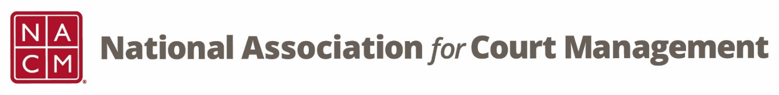

CORE® Committee Meeting
September 28, 3 p.m. ET
Zoom Core® Subcommittee Meeting
Meeting ID: 870 2190 4254
Passcode: 461646

AGENDA:

- Previous Meeting Minutes (attachment)

- CORE Champion
  - Script for Hosts/Presenters at Conferences (attachment) – Dawn Palermo
  - CORE Champion FAQ
  - Website

- CORE News

- Curriculum Review
  - CORE In Practice – Janet Cornell, Richard Lynch, and Brandon Kimura
  - Public Relations – Dawn Palermo, Julie Edwards-McDaniel, Phil Knox, and Theresa Owens

- Other:

- Next Meeting(s):
  - October 26, 2022
  - November 23, 2022
  - December 28, 2022
  - January 25, 2023
  - February 22, 2023
  - March 22, 2023
  - April 26, 2023
  - May 24, 2023
  - June 28, 2023

