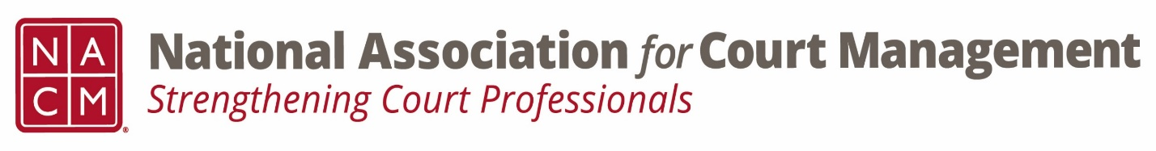

Ethics Conference Call Minutes

Thursday, January 25, 2024
2:00 p.m. (EDT)

On the Call: Stacey Worby, Samantha Wallis, Creadell Webb, Rick Pierce, Peter Kiefer

- October 26, 2023 Minutes were Approved

- Governance Committee Call Report

- Rick reported on the work revising the 3-year National Agenda
- Revisions to the Operations and Procedures Manual were approved.

- Conference Development Committee Call Report

- The selected charity money at the midyear conference will go to Maui relief.

- Any other Committee Call Report

- The ECP Committee is focusing on “leading where you are”
- The CORE Committee is working on “pick your own CORE”
- The DEI Committee will host a pilot training for the Oregon Courts

- New Business

- A markup of the ongoing revisions to the Model Code of Conduct (to date) were attached with the meeting notice for review and comment.

- Meeting concluded and turned over to the Question of Ethics Conversation: Organizational Fairness

Next Meeting- February 22, 2024

