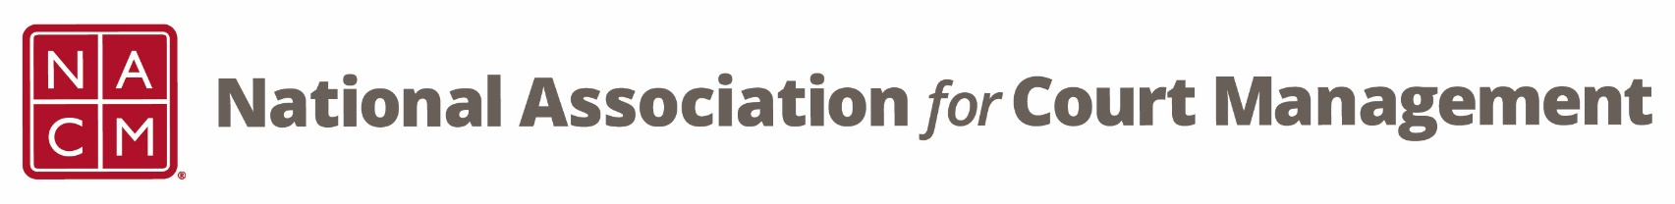

**Conference Development Committee Meeting**

Tuesday, October 15, 2024 at 3 pm EST

**Attendees:**

|  |  |  |  |
| --- | --- | --- | --- |
| **Kelly Hutton** | **Courtney Whiteside** | **Cassie Bradshaw** | **Amy Prenda** |
| **Rick Pierce** | **Dawn Palermo** | **Erica Payne-Santiago** | **Jenny Findsen** |
| **Greg Lambard** | **Creadell Webb** | **Jeffrey Tsunekawa** | **Joe Tommasino** |
| **Jeff Chapple** | **Jude Del Preore** | **Vicky Carlson** | **Janet Cornell** |
| **Melinda Brooks** | **Erin Carr** | **Mark Dalton** |  |

**Minutes:**

1. **Welcome, Introductions, and Minutes**

There were no changes made to the previous meeting minutes. Minutes approved.

1. **Subcommittees**
   1. [**Call for Proposals**](https://nacmnet.org/conferences/call-for-proposals/)
   2. **Hosts – Roger Rand and Kristie Collier**
   3. **Virtual Networking Sessions – Need Volunteer**
   4. **40th Anniversary History – Jude Del Preore**
   5. **Social Events – Kelly Hutton**
   6. **Conference Awards and Conference Scholarships – Rick Pierce**

Kelly Hutton announced that an email went out extending the call for proposals through October 18. The timeline was extended due to additional individuals expressing interest last week. Kelly indicated that emailed those on the review sub-committee to set a date to review the proposals.

Kelly reported that during the officers meeting last Friday staff from Nebraska State Court Administrators office were present to discuss annual conference and how they can assist. Hosting and registration table help was discussed and Kelly will be teaming them up with Roger Rand and Kristie Collier. Dawn Palermo confirmed that there will be a social media post on this this afternoon.

Kelly is still seeking volunteers to act as hosts for virtual attendees. There will be a request in the upcoming Court Express.

Jude Del Preore reminded everyone to check out the past president’s page on the website. There are now photos for all previous presidents and board accomplishments have been completed for each year. Jude will also be headed to Williamsburg to gather historical items for the conference.

Kelly reported that the Sunday evening events in Atlantic City will be moved up about a 30 minutes to allow all activities to be concluded before the kick-off for the Super Bowl. NACM will be hosting a social event at mid-year to celebrate the 40th anniversary. This will be held Monday night at the indoor pool with a DJ. Kelly indicated that while in Omaha a few people completed site visits for the annual social we are looking at having an event similar to that in New Orleans.

Rick Pierce has agreed to take lead on conference awards and scholarships. He and Kelly will work with NCSC staff to get the information out. Rick will then set up a time for the group to review the submissions.

1. **Changing the Name of Shared Interest Group (SIG) Sessions – Kelly Hutton**

After the annual conference this year the board received feedback that the term shared interest group was confusing. The board met this weekend and decided that we change the name to fireside chats.

1. **Other Ideas for the Conferences**

* Pictures and comments from past-presidents (ie table tent/frame photos, slideshow)
* Slideshow with conference photos
  + Jeffrey Tsunekawa will come up with language requesting photos from members for placement in the Court Express and for a social media post
  + Jenny Findsen offered to assist in digitizing any photos
* Band for the Sunday night events welcoming people to the conference
* T-Shirts commemorating the 40th anniversary

1. **NACM/Committee Updates**

* Past-presidents will assist wherever needed.
* The Court Express content deadline is November 15.

**2024-25 Meeting Dates**

November 19, December 17, January 21, March 18, April 15, May 20, June 17