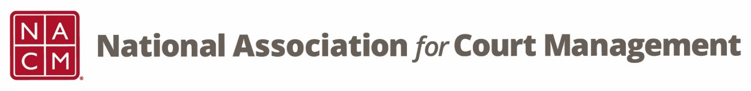

CORE® Committee Meeting
October 26, 2022 at 3 pm ET
Zoom Core® Subcommittee Meeting
Meeting ID: 870 2190 4254
Passcode: 461646

AGENDA:
- Previous Meeting Minutes (attachment)

- CORE Champion
  - General
    - 22 Individual Participants
    - 40 Submissions of Structured Response Tests
  - CORE Champion Video Listing (attachment)
  - Website (In Progress)

- CORE News – What should our next topic be?
  - Release of video links while we build our site
  - Document share last meeting about CORE Champion and Third Party Certifications (created by TJ BeMent)

- Curriculum Review
  - CORE In Practice – Janet Cornell
  - Public Relations – Dawn Palermo

- Other:

- Next Meeting(s):
  - November 23, 2022 – Vote to cancel?
  - December 28, 2022
  - January 25, 2023
  - February 22, 2023
  - March 22, 2023
  - April 26, 2023
  - May 24, 2023
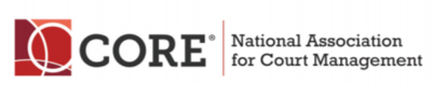
  - June 28, 2023

