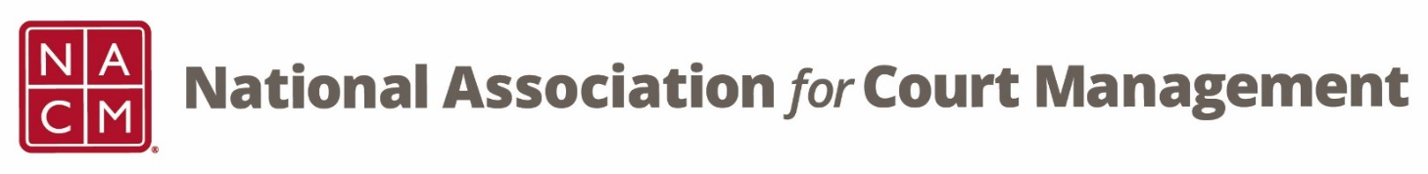

CORE® Committee Meeting
December 28, 2022 at 3 pm ET
Zoom Core® Subcommittee Meeting
Meeting ID: 870 2190 4254
Passcode: 461646

AGENDA:
- Previous Meeting Minutes – Will be posted next week

- CORE Champion
  - General
  - Website (In Progress)
  - Conference Session Updates

- CORE News – Brandon Kimura

- Curriculum/Guide Review
  - CORE In Practice – Janet Cornell
  - Public Relations – Dawn Palermo

- Other:

- Next Meeting(s):
  - January 25, 2023
  - February 22, 2023
  - March 22, 2023
  - April 26, 2023
  - May 24, 2023
  - June 28, 2023

