NACM’s CORE® -
Ethics and the Future of Courts: What We Know Now
February 22, 2022, Conversation Summary
NACM Mid-Year, Bellevue, Washington

Should Courts Allow Employees to Telework?

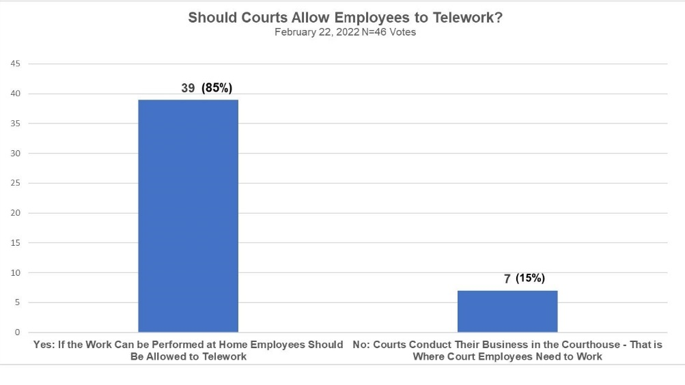
Comments:
Telework is here to stay.
An ethical question remains regarding who gets to telework, who must come into the office, and how fair that teleworking allocation is. Not all jobs are amenable to telework, and few jobs permit full time teleworking.
Is telework a perk or a business assignment decision? How should teleworking be allocated to staff when assigning work projects? Will the ability to telework become a bargaining point on union management negotiations?
Does the perception of telework change when a court has to close for some period time due to an emergency such during COVID?
Confidentiality and record security needs to be addressed while teleworking.
Some courts have statistical productivity reporting functions on their case management systems to track employee productivity while at home; others do not.
Many courts have written “work at home” policies which have proven helpful.
One success story:
Use teams, task tracking, project collaboration, and set expectations. Supervisors and managers need to create weekly checklists. Define expectations and hold employees accountable. Share with the team that telework will work only if everyone is invested in making it work. Employees need to be available.
Should Courts Allow Virtual Trials?

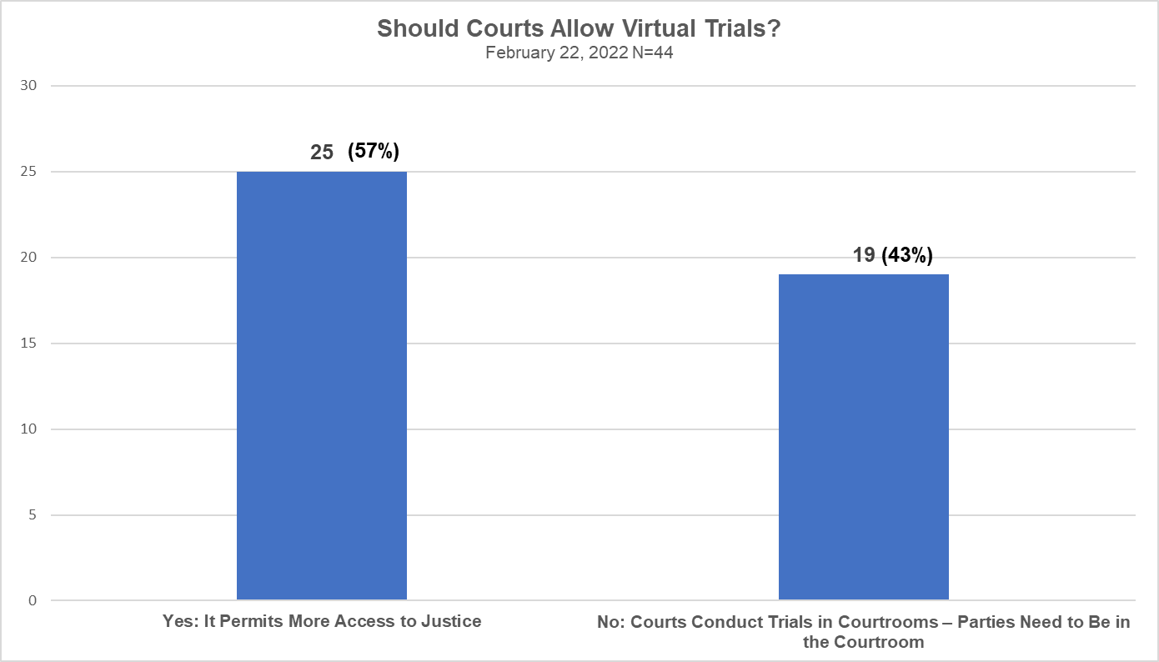

Comments:

Virtual hearings are here to stay.

Few courts have held virtual trial. Multnomah County, Oregon has conducted some. San Bernardino Superior Court has held one fully remote jury trial. Colorado’s 18th Judicial District successfully conducted a hybrid virtual and in-person trial.

The California legislature is considering a bill (SB 241) that will authorize courts to conduct virtual hearings and trials in civil cases and allows parties to voluntarily appear virtually.

Two thirds of the public (66%) is comfortable with video technology and a majority (60%) would use it for jury screenings.

“Zoom Bombing” (hacking into a virtual hearing to disrupt it is a big challenge.

Surprisingly, virtual hearings are more labor intensive than first thought.

One court gives iPads to interpreters.

Should Courts Require Employees to Be Vaccinated?
(Excluding medical and religious exemptions)

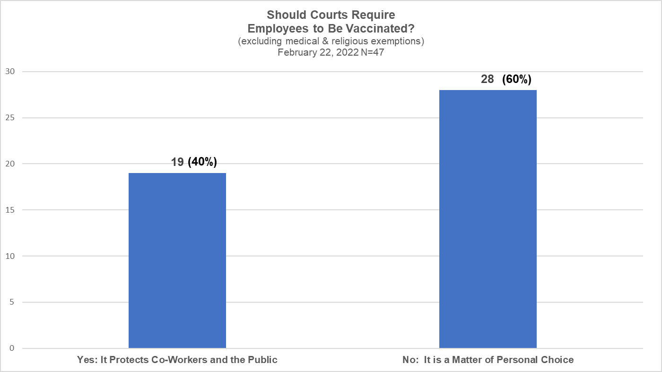

Comments:
There is a huge divide between respondents regarding vaccine mandates.
This poll was taken in the midst of fast-moving changes in public policy regarding vaccinations and wearing masks.
Courts would do well to include contingency policies addressing these areas in their emergency response and continuity of operations plans.

Are Policy Issues and Ethical Questions Mutually Exclusive?
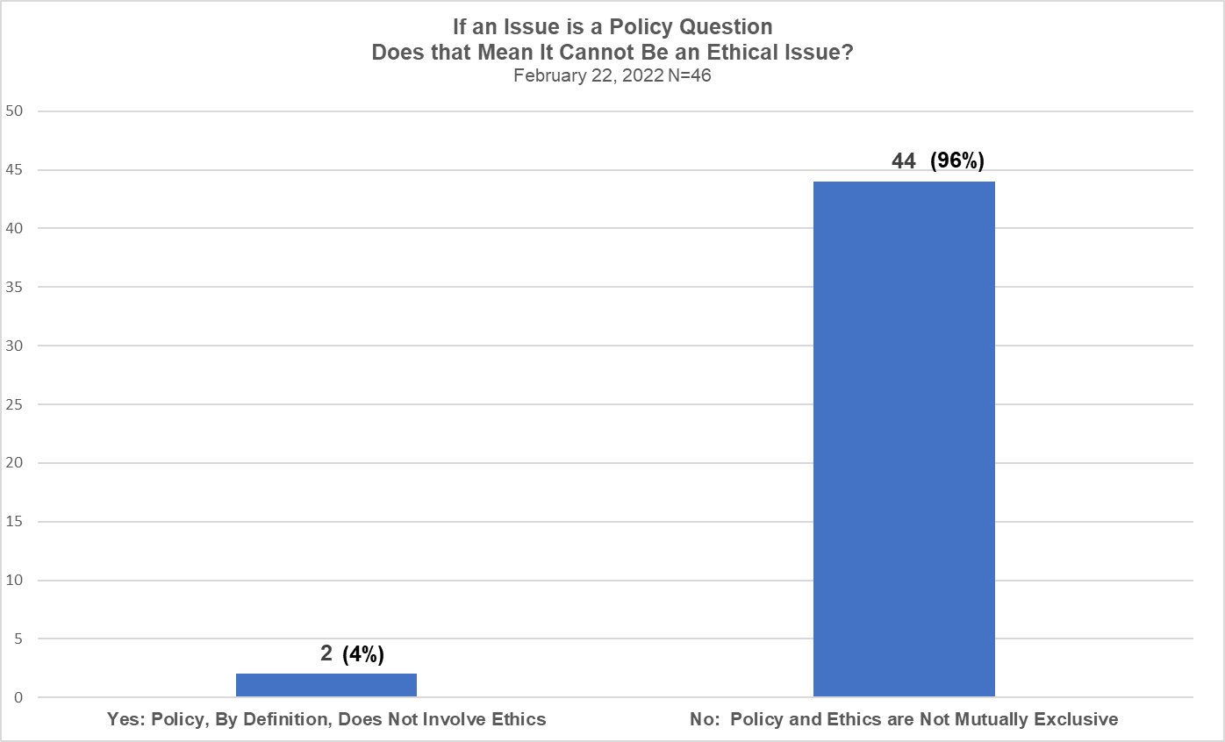
Comments:
There are many areas where policy and ethics appear to intersect, for example:
- Are eviction moratoriums fair if they financially harm landlords?
- Does bail reform permit poor defendants to return home after being arrested or does it give dangerous criminals a “get out of jail free” card?
- Do drug diversion courts permit drug users to avoid a conviction for drug use?
- Are warrant forgiveness events (sometime called “second chances”) fair since a defendant might avoid jail based on what day they surrender.
- Do parking ticket amnesty days permit defendants with parking tickets to enjoy a reduced fine depending on what day they choose to pay their ticket?

An excellent reference is Zach Zarnow and Daniel J. Hall, “Things a Court Manager Should Consider Regarding Remote Work,” National Center for State Courts, and the Joint Technology Committee, August 2021.
For more information: Kristine Swensson, CFO, Superior Court, San Bernardino, California, kswensson@sb-court.org Anabel Romero, Deputy CEO for Court Operations, Superior Court, San Bernardino, California, aromero@sb-court.org
National Center for State Courts “2021 State of the State Courts” Survey
For more information: Jenni Turnidge, Deputy Court Executive, Colorado’s 18th Judicial District, jenni.turnidge@judicial.stat.co.us.

