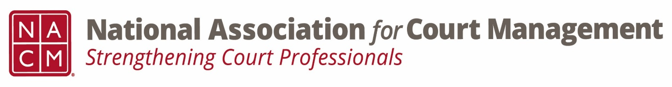

Conference Call of the Ethics Subcommittee
Thursday, August 22, 2024
2:00 p.m. Eastern Time
https://us06web.zoom.us/j/85989294317?pwd=N1yJKqbaZEjoo91rE7uxyz5wbfXi8U.1
Meeting ID
859 8929 4317

- Welcome and Introductions of any new participants.

- Approval of the Minutes from June 23, 2024.

- Governance Committee Call Report
  - Possible amendments to the Ops Manual
    - No Confidence Vote
    - Conference Refunds
  - Possible original resolution
  - Voice of the Profession Task Group volunteers
  - Next meeting 9/4 @ 2:00pm Eastern Time

- Conference Development Committee Call Report
- Cancelled for August- Next meeting 9/17 @ 2:00pm Eastern Time

- Any other Committee Call Report
  - CORE Committee next meeting 9/25 @ 2:00pm Eastern Time

- Open discussion/New Business
    - Conference Ethics Session review
    - AI Guide- Canon 5
    - A Question of Ethics schedule

- A Question of Ethics- Suspended
*NOTE* This portion of the meeting will be recorded and shared with the membership.

- Next Meeting- 9/26 @ 2:00pm Eastern Time

