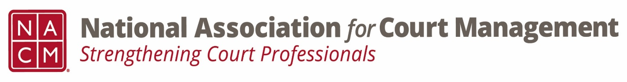

Conference Call of the Ethics Subcommittee

Thursday, February 22, 2024
1:30 p.m. (EDT)
Zoom Meeting ID: 710 387 5466 Passcode: 021675

- Welcome and Introductions of any new participants.

- Approval of the Minutes from January 25, 2024.

- Governance Committee Call Report
- February 13, 2024- Cancelled
- March 6, 2024- Next Meeting
  - Resolutions Subcommittee
  - Bylaws Subcommittee
  - Operations Manual Task Group
  - State of the Profession Task Group
  - Voice of the Profession Task Group

- Conference Development Committee Call Report
- March 12, 2024- Next Meeting
- NOLA- Annual

- Any other Committee Call Report

- Open discussion/New Business
  - Code of Conduct review changes made are attached for the sub-committee’s review. Please review for discussion.
  - Additional work group dates to follow.

- A Question of Ethics- Suspended- Code of Conduct Discussion
*NOTE* This portion of the meeting will be recorded and shared with the membership.

- Next Meeting- March 28, 2024, at 2:00pm EST

