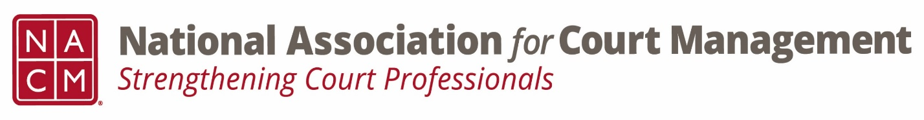

Conference Call of the Ethics Subcommittee

Thursday, February 22, 2024
1:30 p.m. (EDT)
Zoom Meeting ID: 710 387 5466 Passcode: 021675

- Welcome and Introductions of any new participants.

- Approval of the Minutes from January 25, 2024.

- Governance Committee Call Report
- February 13, 2024- Cancelled
- March 6, 2024- Next Meeting
  - Resolutions Subcommittee
  - Bylaws Subcommittee
  - Operations Manual Task Group
  - State of the Profession Task Group
  - Voice of the Profession Task Group

- Conference Development Committee Call Report
- March 12, 2024- Next Meeting
- NOLA- Annual
- The info for the Conference Development Committee: We are receiving great feedback from the midyear, but we don’t have the final evaluations yet. We are finalizing the speakers/presenters for the Annual in New Orleans. We did roll out our NOLA commercial at the midyear and hope to put it out on social media soon. Registration for annual should open by the end of March. The virtual hosting went well with Melinda and Kendra. We will need a new MC for the virtual realm, as Melinda is planning on being onsite at annual. Let Tina know if you are interested!

- Any other Committee Call Report

- Open discussion/New Business
  - Code of Conduct review changes made are attached for the sub-committee’s review. Please review for discussion.
  - Additional work group dates to follow.
    - Courtney will send out dates.

- A Question of Ethics- Suspended- Code of Conduct Discussion
*NOTE* This portion of the meeting will be recorded and shared with the membership.

- Next Meeting- March 28, 2024, at 2:00pm EST
  - Kevin Bowling- AI

