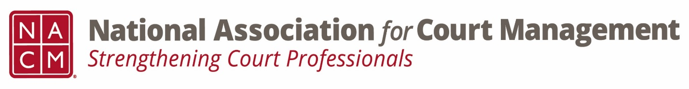

Conference Call of the Ethics Subcommittee

Thursday, February 23, 2023
2:00 p.m. (EDT)
Zoom Meeting ID: 710 387 5466 Passcode: 021675

- Welcome and Introductions of any new participants.
1- L. Alipaz

- Approval of the Minutes from January 26, 2023
Approved

- Governance Committee Call Report
Ops Manual, Resolutions, Annual speech

- Conference Development Committee Call Report
No update- March meeting
Discussion on committee submission for SIG

- Any other Committee Call Report
None

- Open discussion/New Business

- A Question of Ethics- Norman Meyer
*NOTE* This portion of the meeting will be recorded and shared with the membership.

- Next Meeting March 23, 2023.
Volunteer for the March 2023 “Question of Ethics”
Eric Silverberg- next month presenter

