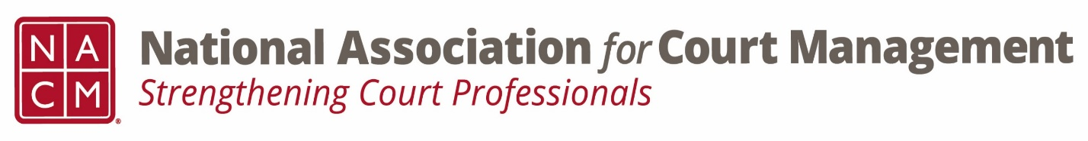
Ethics Subcommittee
Thursday, January 23, 2025
2:00 p.m. Eastern Time
Zoom Link

- Welcome and Introductions of any new participants.

- Approval of the Minutes from September 26, 2024.

- Governance Committee Call Report
  - Original resolution being drafted to honor Mary McQueen- final revision pending committee approval

- Committee Reports
  - Conference Development Committee
  - Communications- Social Media & Website
  - DEI
  - CORE
  - Membership- ECP, State Associations, & International
  - Past Presidents

- Old Business
  - Review NACM Model Code of Conduct and the NACM AI Guide for February working meeting on Canon 5
      - Model Code of Conduct (Adopted 8/2023)
        - Ethics Subcommittee – National Association for Court Management (nacmnet.org)
      - AI Guide
        - NACM Store – National Association for Court Management (nacmnet.org)

- Open discussion/New Business

- A Question of Ethics- Creadell Webb- Using AI Tools Responsibility
*NOTE* This portion of the meeting will be recorded and shared with the membership.

- Next Meeting- 2/27/2025 @ 2:00pm Eastern Time

AI Guide- Canon 5 working meetings- February, April, June

