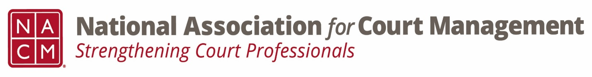
Ethics Subcommittee
Thursday, January 23, 2025
2:00 p.m. Eastern Time
Zoom Link

- Welcome and Introductions of any new participants.
11- Courtney Whiteside, Peter Kiefer, Roger Rand, Creadell Webb, Kelly Hutton, Alison Braaten, Amy Emig, Andrea Powers, Nicholas (Nick) Brackley, Tina Mattison, Norman Meyer

- Approval of the Minutes from Oct 26/Nov 21, 2024
Approved

- Governance Committee Call Report
  - Original resolution being drafted to honor Mary McQueen- final revision pending committee approval

- Committee Reports
  - (Kelly) Conference Development Committee- Update on Atlantic City
  - (Courtney) ECP- Choosing a charity for the annual conference in Omaha
  - (Creadell) DEI- 3rd Wed monthly
  - (Courtney) Membership- New member calls
  - (Norman and Roger) CORE- webinar Monday 1/27 3 ET, revision Case Flow/Work Flow

- Old Business
  - Review NACM Model Code of Conduct and the NACM AI Guide for February working meeting on Canon 5
      - Model Code of Conduct (Adopted 8/2023)
        - Ethics Subcommittee – National Association for Court Management (nacmnet.org)
      - AI Guide
        - NACM Store – National Association for Court Management (nacmnet.org)
        - (Roger) Revisions twice a year- January and July with notations of revisions- please review for February meeting

- Open discussion/New Business
(Norman) 40th Anniversary- special workgroup with Jude.

- A Question of Ethics- Creadell Webb- Using AI Tools Responsibility
*NOTE* This portion of the meeting will be recorded and shared with the membership.

- Next Meeting- 2/27/2025 @ 2:00pm Eastern Time

AI Guide- Canon 5 working meetings- February, April, June

