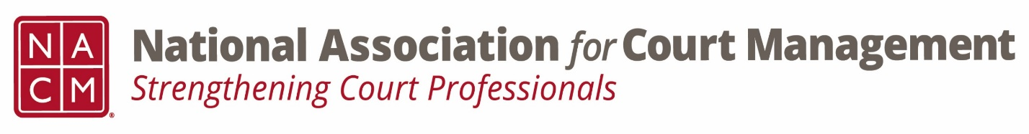

Conference Call of the Ethics Subcommittee
Thursday, May 23, 2024
2:00 p.m. (EDT)
Zoom Meeting ID: 710 387 5466 Passcode: 021675

- Welcome and Introductions of any new participants.

- Approval of the Minutes from April 25, 2024.

- Governance Committee Call Report
- Update
  - Resolutions Subcommittee
  - Bylaws Subcommittee
  - Operations Manual Task Group
  - State of the Profession Task Group
  - Voice of the Profession Task Group

- Conference Development Committee Call Report
- NOLA- Annual

- Any other Committee Call Report

- Open discussion/New Business
  - Additional work group dates
    - May 28th 1:30-3:30 EST- Cancelled.
    - June 11th 1:30-3:30 EST

- A Question of Ethics- Suspended- Code of Conduct Review- Initial Review of drafted changes.
*NOTE* This portion of the meeting will be recorded and shared with the membership.

- Next Meeting- June 27, 2024, at 2:00pm EST
  - Volunteer needed to present A Question of Ethics.

