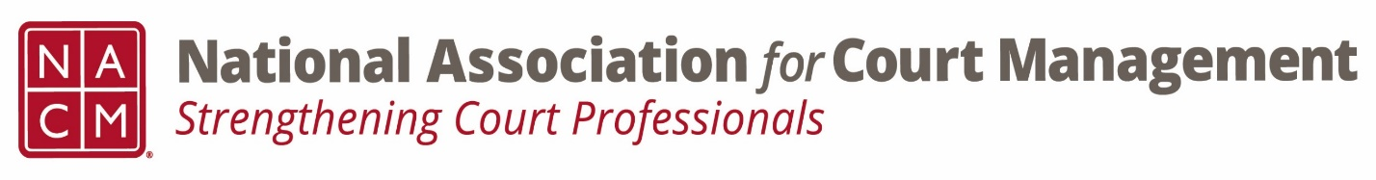

Conference Call of the Ethics Subcommittee
Thursday, May 23, 2024
2:00 p.m. (EDT)
Zoom Meeting ID: 710 387 5466 Passcode: 021675

- Welcome and Introductions of any new participants.
Meeting called to order at 1:05

- Approval of the Minutes from April 25, 2024.
Approved

- Governance Committee Call Report
- Update
  - Resolutions Subcommittee
Update post conference
  - Bylaws Subcommittee
Board discussion at 6/4 meeting
  - Operations Manual Task Group
Completed, pending review and approval at 6/4 board meeting
  - State of the Profession Task Group
Progress is being made
  - Voice of the Profession Task Group
Meeting on 5/28 at 2:00est

- Conference Development Committee Call Report
- NOLA- Annual
All set. Look for opportunities to help with hosting duties.

- Any other Committee Call Report
Membership Committee- ongoing discussions on distribution of membership survey.

- Open discussion/New Business
  - Additional work group dates
    - May 28th 1:30-3:30 EST- Cancelled.
    - June 11th 1:30-3:30 EST

- A Question of Ethics- Suspended- Code of Conduct Review- Initial Review of drafted changes.
*NOTE* This portion of the meeting will be recorded and shared with the membership.
Completed the intro and Canon 1. Add previous participating committee members to the end.

- Next Meeting- June 27, 2024, at 2:00pm EST
  - Volunteer needed to present A Question of Ethics.
Information to follow.

