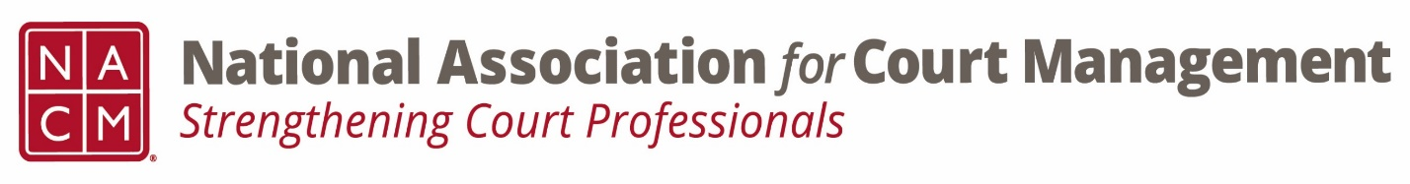

Conference Call of the Ethics Subcommittee

Thursday, August 24, 2023
2:00 p.m. (EDT)
Zoom Meeting ID: 710 387 5466 Passcode: 021675

- Welcome and Introductions of any new participants.

- Approval of the Minutes from July 27, 2023.

- Governance Committee Call Report

- Conference Development Committee Call Report

- Any other Committee Call Report

- Open discussion/New Business
  - Question of Ethics series planning and publication
    - October
    - January (Skipping November/December)
    - March
  - Website changes submitted as agreed upon.
  - Code of Conduct review plan

- A Question of Ethics- Ethical challenges with technology and culture when performing court duties. Presented by Creadell Webb
*NOTE* This portion of the meeting will be recorded and shared with the membership.

- Next Meeting September 28, 2023
  - Volunteer for August 2023 “Question of Ethics” topic

