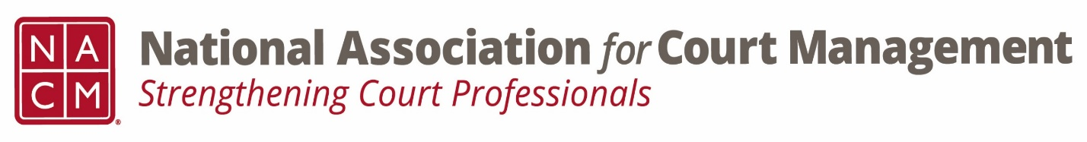

Conference Call of the Ethics Subcommittee

Thursday, August 24, 2023
2:00 p.m. (EDT)
Zoom Meeting ID: 710 387 5466 Passcode: 021675

- Welcome and Introductions of any new participants.

- Approval of the Minutes from July 27, 2023.

- Governance Committee Call Report
  - Ops Manual with board for review
  - Additional changes regarding mission and vision statement in discussion

- Conference Development Committee Call Report
  - Discussion on a future conference with IACA
  - Conference feedback
  - Discussion on conference structure

- Any other Committee Call Report

- Open discussion/New Business
  - Question of Ethics series planning and publication
    - October- Samantha Wallis (Employee Tracking- Gauging Performance)
    - January (Skipping November/December)- Peter Kiefer
    - March
  - Website changes submitted as agreed upon.
  - Code of Conduct review plan
    - Plain language check
    - Opening section to be reviewed for comment for September meeting and will move on to Cannon 1 if time allows.
    - Request for send out to membership for comment or items to be included. Ambiguities in the code and things that are missing.

- A Question of Ethics- Ethical challenges with technology and culture when performing court duties. Presented by Creadell Webb
*NOTE* This portion of the meeting will be recorded and shared with the membership.

- Next Meeting September 28, 2023
  - Volunteer for October 2023 & January 2024 “Question of Ethics” topic
  - October 23- Samantha Wallis (Employee Tracking- Gauging Performance)
  - January 24- Peter Kiefer (TBD)

