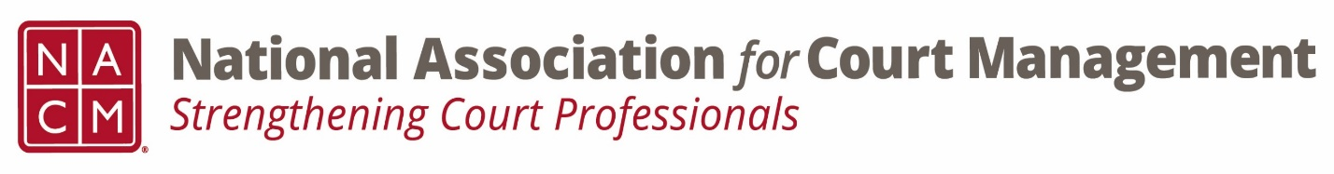

Conference Call of the Ethics Subcommittee

Thursday, January 25, 2024
2:00 p.m. (EDT)
Zoom Meeting ID: 710 387 5466 Passcode: 021675

- Welcome and Introductions of any new participants.

- Approval of the Minutes from October 26, 2023.

- Governance Committee Call Report
- On going discussion on a drafting a NACM resolution.
- Beginning discussions on the State of the Profession

- Conference Development Committee Call Report
- All is set for mid-year. Need for session hosts.

- Any other Committee Call Report

- Open discussion/New Business
  - Code of Conduct review changes made are attached for the sub-committee’s review. Please review for discussion on January 30th work group meeting and the regular February meeting.
  - Additional work group dates to follow.

- A Question of Ethics- Pete Kiefer: Organizational Fairness
*NOTE* This portion of the meeting will be recorded and shared with the membership.

- Next Meeting- January 20, 2024, at 2:00pm CST work group meeting and February 22, 2024, regular meeting but will consist of working on the Code of Conduct. It has been requested by another committee that we move our February 22nd meeting to 12:30pm ET.

