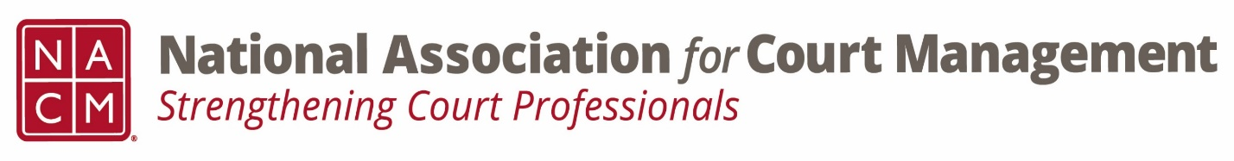

Conference Call of the Ethics Subcommittee

Thursday, January 26, 2023
2:00 p.m. (EDT)
Zoom Meeting ID: 710 387 5466 Passcode: 021675

- Welcome and Introductions of any new participants.
- Approval of the Minutes from October 27, 2022
- Governance Committee Call Report-
Working on resolutions, Operations Manual, and State of the Profession Address, etc.

- Conference Development Committee Call Report-
Set to go for mid-year, final stages of speakers for annual, committees can drive a SIG session.

- Any other Committee Call Report-
ECP: service project gearing up

- Open discussion/New Business

- A Question of Ethics- Norman Meyer
*NOTE* This portion of the meeting will be recorded and shared with the membership.
Will continue with Part 2 in February

- Next Meeting February 23, 2023.
Volunteer for the February 2023 “Question of Ethics”

