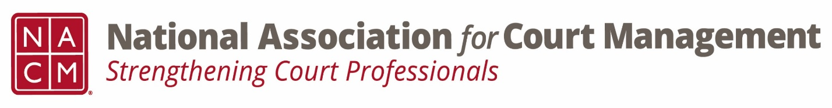

Conference Call of the Ethics Subcommittee

Thursday, October 26, 2023
2:00 p.m. (EDT)
Zoom Meeting ID: 710 387 5466 Passcode: 021675

- Welcome and Introductions of any new participants.

- Approval of the Minutes from September 28, 2023. (Corrected minutes were submitted to NCSC and posted.)

- Governance Committee Call Report
- The changes to the operations manual were accepted by the board.
- Resolutions promulgated by NACM were discussed and encouraged.
- Subcommittee discussion regarding DEI being included in the mission and vision statement or a separate statement and webpage.

- Conference Development Committee Call Report
- Call for proposals closed.
- Subcommittee will be reviewing the proposals.

- Any other Committee Call Report

- Open discussion/New Business
  - Code of Conduct review changes made in September was send with agenda. Please review and make comment to be ready to discuss at the next meeting.
  - Discussion was had regarding additional meetings for the specific purpose of review the code of conduct. There are no meetings set for November and December, but do we want to add a few dates in the interest of expeditious completion? Please do so, if that is the wish of the group.

- A Question of Ethics- Samantha Wallis: Employee Tracking & Gauging Performance
*NOTE* This portion of the meeting will be recorded and shared with the membership.

- Next Meeting- January 25, 2024

