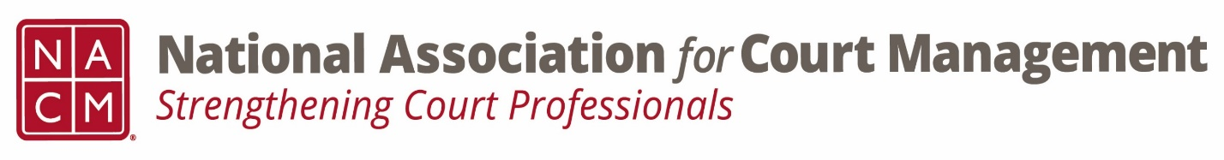

Ethics Conference Call Minutes

Thursday, October 26, 2023
2:00 p.m. (EDT)

On the Call: Cecelia Garner, Samantha Wallis, Erika Schmid, Norman Meyer, Karl Thoennes, Creadell Webb, Lizzie Alipaz, Rick Pierce, Peter Kiefer

- Welcomed Erika Schmid and Lizzie Alipaz

- September 28, 2023- Minutes Approved

- Governance Committee Call Report
- The changes to the operations manual were accepted by the board.
- Resolutions promulgated by NACM were discussed and encouraged.
- Subcommittee discussion regarding DEI being included in the mission and vision statement or a separate statement and webpage.
- Rick mentioned that the Board met the previous week in New Orleans

- Conference Development Committee Call Report
- Call for proposals closed.
- The subcommittee is reviewing the proposals.

- Any other Committee Call Report

Karl and Peter mentioned that they facilitated a discussion on ethics at the Early Career Professionals Committee meeting.
The CORE Committee met. Greg Lambard is looking for volunteers to help work on various aspects of the CORE.

- Open discussion/New Business
  - The committee members thought the changes to the Code of Conduct looked good. No additional comments.
  - No one wanted to meet prior to the next regularly scheduled meeting in January.

Norman mentioned that the National Center for State Courts has recently come out with a listing of State Ethics Codes. He suggested that the Ethics Committee cross-correlate the National Center’s list with the one the Ethics Committee put together.

Meeting concluded and turned over to Samantha Wallis who facilitated the Question of Ethics Conversation: Employee Tracking & Gauging Performance

- Next Meeting- January 25, 2024

