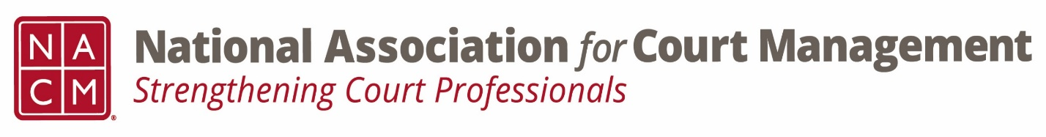

Ethics Subcommittee
Thursday, November 21, 2024
(rescheduled from 10/26/24)
2:00 p.m. Eastern Time
Zoom Link

- Welcome and Introductions of any new participants.
  - Roger Rand, Pete Keifer, Stacey Worby, Ellen Haines, Jeff Chapple, Creadell Webb

- Approval of the Minutes from September 26, 2024.
  - Approved

- Governance Committee Call Report
  - Original resolution for the removal of “master“ from court titles final review and present to board
    - Passed
  - Original resolution being drafted to honor Mary McQueen
    - No draft as of yet

- Conference Development Committee Call Report
  - 40-year committee- get memorabilia to Jude

- Any other Committee Call Report

- Open discussion/New Business
  - Review NACM Model Code of Conduct and the NACM AI Guide for February working meeting on Canon 5
      - Model Code of Conduct (Adopted 8/2023)
        - Ethics Subcommittee – National Association for Court Management (nacmnet.org)
        - Work to begin at the February meeting
      - AI Guide
        - NACM Store – National Association for Court Management (nacmnet.org)
        - Communications subcommittee starting in December

- A Question of Ethics- Data Literacy with Roger Rand
*NOTE* This portion of the meeting will be recorded and shared with the membership.

- Next Meeting- 1/23/2025 @ 2:00pm Eastern Time

December- No meeting
January- Using AI Tools Responsibility (Creadell Webb)
AI Guide- Canon 5 working meetings- February, April, June

