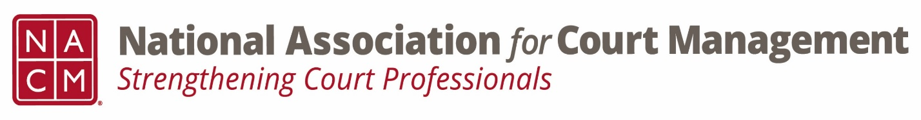

Conference Call of the Ethics Subcommittee
Thursday, September 26, 2024
3:00 p.m. Eastern Time
https://us06web.zoom.us/j/85989294317?pwd=N1yJKqbaZEjoo91rE7uxyz5wbfXi8U.1
Meeting ID
859 8929 4317

- Welcome and Introductions of any new participants.

- Approval of the Minutes from August 22, 2024.

- Governance Committee Call Report
  - 9/4 meeting canceled
  - Next meeting 10/2 @ 3:00pm Eastern Time

- Conference Development Committee Call Report
- Next meeting 10/15 @ 3:00pm Eastern Time

- Any other Committee Call Report
  - CORE Committee next meeting 9/25 @ 3:00pm Eastern Time

- Open discussion/New Business

- A Question of Ethics- Problem Analysis & Problem Solving (Pete Kiefer)
*NOTE* This portion of the meeting will be recorded and shared with the membership.

- Next Meeting- 10/24 @ 3:00pm Eastern Time
October- Data Literacy (Roger Rand)
November- No meeting
December- No meeting
January- Using AI Tools Responsibility (Creadell Webb)
AI Guide- Canon 5 working meetings- February, April, June

