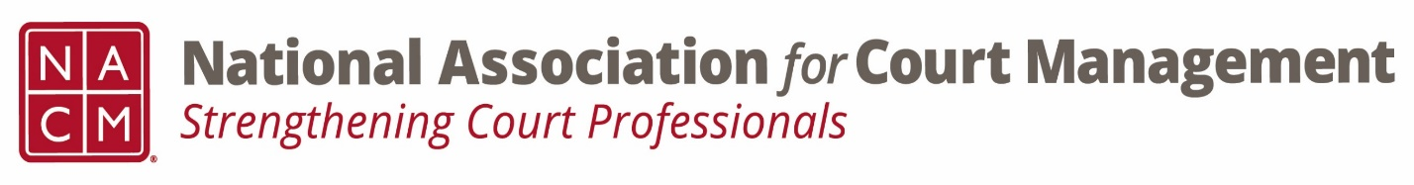

Conference Call of the Ethics Subcommittee

Thursday, April 27, 2023
2:00 p.m. (EDT)
Zoom Meeting ID: 710 387 5466 Passcode: 021675

- Welcome and Introductions of any new participants.

- Approval of the Minutes from Feburary 23, 2023. (March meeting was cancelled.)

- Governance Committee Call Report

- Conference Development Committee Call Report

  - Suggestion for Ethics Committee submission regarding finding ethical candidates

- Any other Committee Call Report

- Open discussion/New Business

- A Question of Ethics- Eric Silverberg
*NOTE* This portion of the meeting will be recorded and shared with the membership.

- Next Meeting May 25th or June 22nd, 2023
Volunteer for the May/June 2023 “Question of Ethics”
Volunteer to run the May/June meeting

