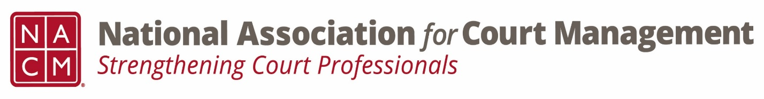

Conference Call of the Ethics Subcommittee

Thursday, April 27, 2023
2:00 p.m. (EDT)
Zoom Meeting ID: 710 387 5466 Passcode: 021675

- Welcome and Introductions of any new participants.
8 participants on the call

- Approval of the Minutes from February 23, 2023. (March meeting was cancelled.)

- Governance Committee Call Report
Kent Pankey- update on bylaw changes, state of the profession, resolutions, ops manual

- Conference Development Committee Call Report
  - Suggestion for Ethics Committee submission regarding finding ethical candidates- table until after the Ethics session at the Annual.

- Any other Committee Call Report

- Open discussion/New Business
Cancel May. Eric Silverberg to run the June meeting
Board Candidate and Award Nomination announcement

- A Question of Ethics- Eric Silverberg
*NOTE* This portion of the meeting will be recorded and shared with the membership.

- Next Meeting June 22nd, 2023
Volunteer for the June 2023 “Question of Ethics” -Business meeting only
Volunteer to run the June meeting- Eric Silverberg

