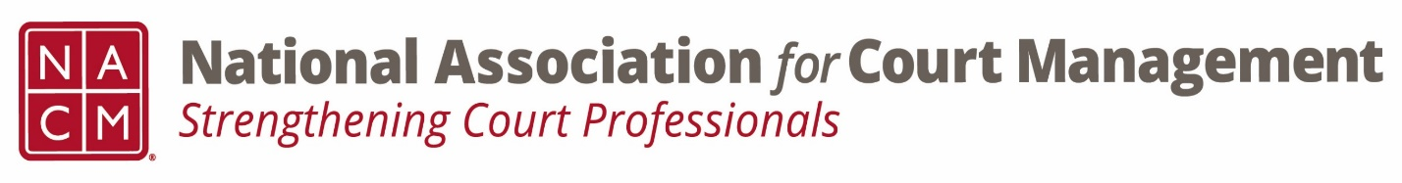

Conference Call of the Ethics Subcommittee

Thursday, July 27, 2023
2:00 p.m. (EDT)
Zoom Meeting ID: 710 387 5466 Passcode: 021675

- Welcome and Introductions of any new participants.

- Approval of the Minutes from June 22, 2023. (No minutes taken.)

- Governance Committee Call Report
  - Chair and Co-Chair
  - Bylaw passage
  - 2023/2024 committee priorities

- Conference Development Committee Call Report

- Any other Committee Call Report

- Open discussion/New Business
  - Conference feedback
  - Ethics session feedback
  - 2023/2024 Schedule for Ethics Sub-Committee
  - Question of Ethics series planning and publication
  - Website changes

- A Question of Ethics- Suspended until the August Meeting
*NOTE* This portion of the meeting will be recorded and shared with the membership.

- Next Meeting August 24, 2023
  - Volunteer for August 2023 “Question of Ethics” topic

