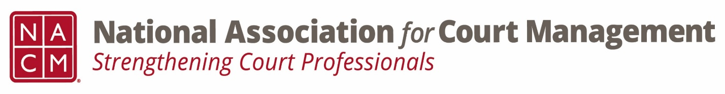

Conference Call of the Ethics Subcommittee

Thursday, July 27, 2023
2:00 p.m. (EDT)
Zoom Meeting ID: 710 387 5466 Passcode: 021675

- Welcome and Introductions of any new participants.

- Approval of the Minutes from June 22, 2023. (No minutes taken.)

- Governance Committee Call Report
  - Chair and Co-Chair
  - Bylaw passage-
    - Low turn out for the number of attendees concerning. Possible challenge regarding technology. Location of the poll or “scheduling” of the vote
    - Suggestion to simplfy the process.
    - Better instruction on “how to”
    - A way to vote without attending
    - Open voting all conference for bylaw changes- specified time for elections
  - 2023/2024 committee priorities- Dawn Palermo
    - Ethics Code
    - Operations Manual Update
    - Governanace website

- Conference Development Committee Call Report
  - Nothing to report at this time.
  - Suggestion for plenary session

- Any other Committee Call Report
  - Joint Technology Committee- may have ethics submissions for dissection
  - AI discussions- digital evidence, plagiarism, etc.
  - Communications- AI guide

- Open discussion/New Business
  - Conference feedback
    - QR code went well.
    - 59 CORE Submissions for review
  - Ethics session feedback
    - Technological challenges- Polling
    - Session went well
    - Submission for annual
    - Suggestion for plenary session- AI ethics plenary session
  - 2023/2024 Schedule for Ethics Sub-Committee
    - Monthly meeting & bi-monthly recording
  - Question of Ethics series planning and publication
    - Think of a tag line for ethics
    - Blast emails- Monthly
    - Upcoming meeting topics
      - Court Manager (longer submissions- article)- Qtrly- Due 10/3- send to Dawn
      - Court Express (snapshot)- Bi-monthly (opposite Court Manager)
        - Ideal for our needs
        - Janet Cornell- highlight sub-committee
  - Website changes
    - Mock up approved with minor edit
  - **Add on** Review and Dive into the Code of Conduct. Request of Brandon Kimura with interest shown by Cheryl Stone and Nicole Garcia.
    - Are there any specific items to review? (board meeting end of August)

- A Question of Ethics- Suspended until the August Meeting
*NOTE* This portion of the meeting will be recorded and shared with the membership.

- Next Meeting August 24, 2023
  - Volunteer for August 2023 “Question of Ethics” topic- Creadell Webb

