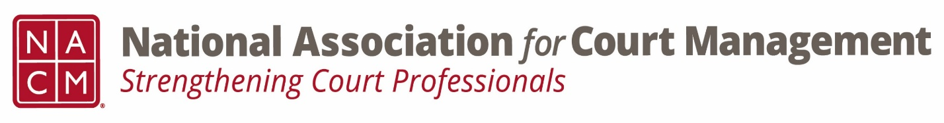

Conference Call of the Ethics Subcommittee

Thursday, September 28, 2023
2:00 p.m. (EDT)
Zoom Meeting ID: 710 387 5466 Passcode: 021675

- Welcome and Introductions of any new participants.

- Approval of the Minutes from August 24, 2023. (Corrected minutes were submitted to NCSC and posted.)

- Governance Committee Call Report
- To be held the following week. Expected response from the board on Ops Manual.

- Conference Development Committee Call Report
- Call for proposals closed October 6

- Any other Committee Call Report

- Open discussion/New Business
  - Code of Conduct review of introduction and Canon 1
    - Completed the opening few paragraphs.
    - Discussion on addition of canons regarding treatment/specialty courts.
    - Discussion on adding additional meetings to focus on review.
    - Edits to be emailed out.

- A Question of Ethics- Suspended to October meeting.
*NOTE* This portion of the meeting will be recorded and shared with the membership.

- Next Meeting October 26, 2023
  - October “Question of Ethics” presenter, Samantha Wallis, “Employee Tracking and Gauging Performance”

