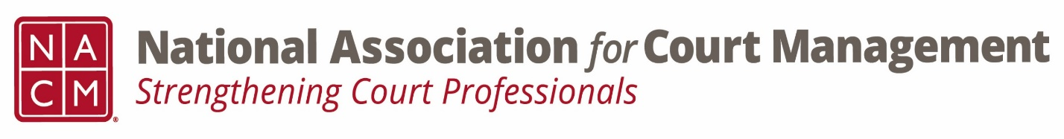

Conference Call of the Ethics Subcommittee

Thursday, September 22, 2022
2:00 p.m. (EDT)
Zoom Meeting ID: 710 387 5466 Passcode: 021675

- Welcome and Introductions of any new participants
- Approval of the Minutes from August 25, 2022
- Governance Committee Call Report-

- Conference Development Committee Call Report-

- Any other Committee Call Report-
- Open discussion/New Business

- A Question of Ethics- Karl Thoennes
*NOTE* This portion of the meeting will be recorded and shared with the membership.

- Next Meeting October 27, 2022.
Joe Tommasino to present the “Question of Ethics”

