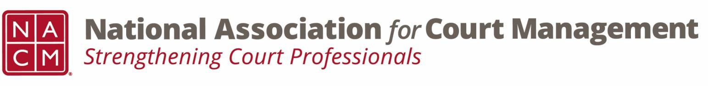

# **Governance Committee Agenda**

**October 2, 2024, 3:00 p.m. Eastern via Zoom**

Zoom link: https://zoom.us/j/93807989162?pwd=ZjV5S0pDOW1WalN6eFYwakkzTm03Zz09

**Chair:** [Nicole Zoe García](mailto:nicole@nacmnet.org) **Vice Chair**: [Courtney Whiteside](mailto:courtney@nacmnet.org)

**Committee Page**

1. **Call to Order**
2. **Reports of Sub-Groups**
   1. Ethics Subcommittee – Peter Kiefer
   2. Resolutions Subcommittee – Nicole Garcia
      * Potential Original Resolution re Change in nomenclature from “special master” to “court-appointed neutral” – Discussion by all
3. **Unfinished Business**
4. **New Business**
   1. 2025 Conferences Call for Proposals!
5. **NACM Committee Updates**
6. **Adjourn**