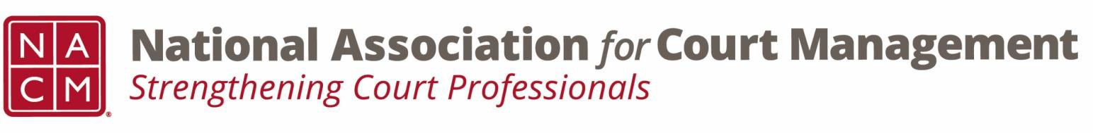

# **Governance Committee Agenda**

**December 4, 2024, 3:00 p.m. Eastern via Zoom**

Zoom link: <https://us06web.zoom.us/j/81227189771?pwd=bRWbW5ruaslCR6VMp5aM1MEXPmXUPP.1>

**Chair:** [Nicole Zoe García](mailto:nicole@nacmnet.org) **Vice Chair**: [Courtney Whiteside](mailto:courtney@nacmnet.org)

[**Committee Page**](https://nacmnet.org/governance-committee/)

1. **Call to Order**
2. **Approval of Minutes**
3. **Reports of Sub-Groups**
   1. Ethics Subcommittee – Courtney Whiteside
   2. Resolutions Subcommittee – Nicole Garcia
      * Update on Original Resolution re Change in nomenclature from “special master” to “court-appointed neutral”
      * Draft Original Resolution in Recognition of Mary McQueen – Discussion by all
4. **New Business**
   1. Strategic Plan/Annual Goals
   2. Court Employee Appreciation Toolkit
5. **Unfinished Business**
6. **NACM Committee Updates**
7. **Adjourn**