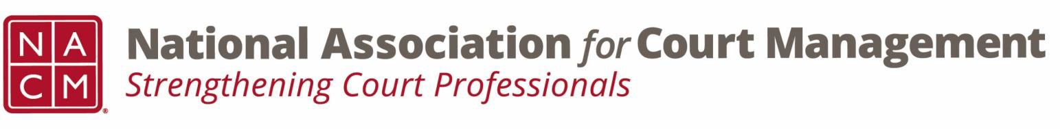

# **Governance Committee Agenda**

**August 7, 2024, 3:00 p.m. Eastern via Zoom**

Zoom link: https://zoom.us/j/93807989162?pwd=ZjV5S0pDOW1WalN6eFYwakkzTm03Zz09

**Chair:** [Nicole Zoe García](mailto:nicole@nacmnet.org) **Vice Chair**: [Courtney Whiteside](mailto:courtney@nacmnet.org)

**Committee Page**

1. **Call to Order**
2. **Reading and Approval of Minutes of prior meeting**
3. **Annual Conference Recap**
4. **Reports of Sub-Groups**
   1. Ethics Subcommittee – Courtney Whiteside, Chair
   2. Resolutions Subcommittee – Nicole Garcia
      * Potential Original Resolution re Change in nomenclature from “special master” to “court-appointed neutral”
   3. Bylaws Subcommittee – Nicole Garcia
      * APPROVED - Proposed amended mission and proposed amended vision
   4. Operations Manual Task Group
      * Recent amendments – Membership cancelation
      * Additional need for amendments regarding a policy pertaining to refunds of scholarships awarded for conference attendance
   5. Voice of the Profession Task Group – Update
5. **Unfinished Business**
6. **New Business**
   1. Court Employee Appreciation
7. **NACM Committee Updates**
8. **Adjourn**