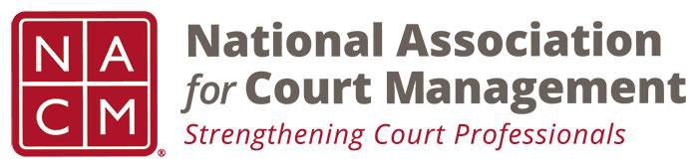

NACM MEMBERSHIP SERVICES COMMITTEE MEETING
Tuesday, April 9, 2019, 11AM ET
+1 (872) 240-3412 Access Code: 922-550-533
https://global.gotomeeting.com/join/922550533

Call to Order Michelle Dunivan
Welcome and Roll Call Michelle Dunivan
Board Meeting Recap Michelle Dunivan
Subcommittees:
- State Associations TJ BeMent
- ECP Angie VanSchoick
Strategic Planning Priorities Jeffrey Tsunekawa
Recruitment and new member subcommittee Randall Soderquist
Membership Appreciation event Jeffrey Tsunekawa
Membership Benefits write up Michelle Dunivan
Awards Jeffrey Tsunekawa
Regional Coordinators Michelle Dunivan
Announcements Michelle Dunivan
Board Candidacy
Scholarship Raffle
Career Fair
New Business
Adjourn

Meeting Schedule
  - May 7, 2019
  - June 4, 2019
  - July 24, 2019- At Annual Conference

