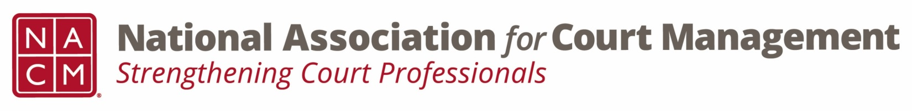

COMMUNICATIONS COMMITTEE
Thursday, August 9, 2018 - 4:00 P.M. ET
Teleconference: 800-503-2899 | 2591537; International Call Number: 303-248-0817
Committee Web Page

AGENDA

- Welcome/Call to Order/Roll Call

- Welcome New Committee Members

- Publications Updates
  - Court Manager – Tasha Ruth

NACM Annual Conference Articles
          - General Conference Summary
          - Social Event
          - Awards
          - Vendor Exhibit
  - Court Express – Jeffrey Tsunekawa

- Quarterly Webinars
  - 3rd Quarter Webinar - Debrief of Joint Technology Committee Projects Webinar
  - 4th Quarter Webinar - Domestic Violence Guide – November 8 at 2:00 p.m. EST, Julie Dybas

- Guide

Plain Language Guide Update – Aurora Zamora

- Social Media Update – Kathy Griffin

- Website Update – Jeffrey Tsunekawa

- July 21, 2018 Board Meeting Update

  - Revised Structure for Communications Committee
  - Webinar Access Policy

  - Webinar Sponsorship Policy

  - Proofreading Checklist for NACM Communications

  - Communications Plan

  - Guide Fee Policy

  - 2019 Advertisement Rates

- New Business
  - Education Committee, T.J. BeMent
  - Communications Committee Vice Chair
  - Social Media Coordinator
  - 2019 Webinars
  - 2019 NACM Guide
  - Shared Interest Groups – Continuing the Conversation beyond the Conference

- Next Meeting: September 13, 2018 at 4:00 EST

