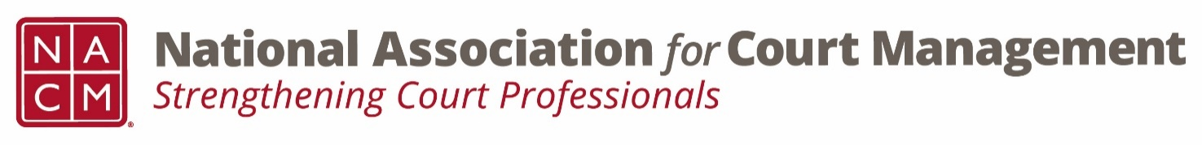

**BOARD CONFERENCE CALL**

**Board Page:** <https://nacmnet.org/board.html>

**Tuesday, April 3, 2018, 2:00 – 4:00 pm ET**

**(800) 503-2899 – Access Code: 2591537**

**AGENDA**

**2:00 President’s Report (40 mins.)** *Vicky Carlson*

1. Approval of Minutes from Midyear Board Meeting, February 10, 2018 (<https://nationalcenterforstatecourts.box.com/s/s8k2q4uvm5proyqfrrvlva2vyu9p9jd0> )
2. Approval of Minutes from Board Call March 12, 2018

(<https://nationalcenterforstatecourts.box.com/s/8kk5uos5rrvqdk9qz4z9fzzzcupkqarf> )

1. Board Conflict of Interest Policy – Any updates?
2. President Travel
   1. NCJFCJ
   2. COSCA
3. Termination of MOU between NACM and AIA 
4. Committee Chair Reports and committee awards at annual conference
5. Webinar Sponsorships
6. Guests at annual conference board meeting
7. Notification of Board changes to membership

**2:40 President-Elect’s Report (5 mins.)** *Paul DeLosh*

1. Conference Development Committee report

**2:45 Vice-President’s Report (5 mins.)** *Will Simmons*

**2:50 Secretary/Treasurer’s Report (5 mins.)** *TJ BeMent*

1. Budget update

**2:55 Membership Committee Report (10 mins.)** *Jeff Chapple*

1. Donation Solicitation of Members – future of NACM Cares
2. Scholarship Fundraiser – Fun Run Funds

**3:05 Governance Committee Report (25 mins.)**  *Greg Lambard*

1. Resolutions for Consideration:

2018 Supported Resolution #1: [In Support of COSCA Resolution in Support of Principles of Bail](https://nacmnet.org/sites/default/files/COSCA%20resolution%20in%20support%20of%20principles%20of%20bail.pdf)

2018 Supported Resolution #2: [In Support of COSCA Resolution to Expand CASA Funding](https://nacmnet.org/sites/default/files/COSCA%20resolution%20to%20expand%20CASA%20funding.pdf)

NACM 2018 Resolution #1: [In Recognition of Maureen Conner, Ph.D. and the Michigan State University Judicial Administration Program](https://nacmnet.org/sites/default/files/Resolution%203%20MSU.pdf)

1. Operations Manual update
2. State of the Profession Address

**3:30 Past President’s Report (5 mins.)** *Scott Griffith*

1. Nominations Committee
2. Past President Conference Registration
3. Nomination of Candidate/Declaration of Candidacy Deadlines

**3:35 NCSC Update (5 mins.)** *Jennifer Haire*

**3:40 New Business/Open Discussion** *All*

**Executive Session (if needed)** *Board*

**Important Upcoming Dates and Events**

* April 5 – Committee Chairs Call, 3 p.m.
* April 13 – [Most] Awards Submissions Due
* April 15 – Nominations for Board Candidates Due
* May 1 – McQueen Award Nomination Deadline
* May 1 – Officers Call, 2-4 p.m.
* May 3 – New Board Members Call
* May 4 – Declaration of Candidacy Form Due
* May 7 – Court Express Deadline
* May 15 – Committee Recognition Award Names (2-3 per committee)

due to Janet

* May 17 – Trauma Awareness Webinar, 2 p.m.
* June 5 – Board Call, 2-4 p.m.
* July 10 – Committee Reports for Board Book Due
* July 20 – Officer Meeting at Annual Conference – Atlanta, GA
* July 21 – Board Meeting at Annual Conference – Atlanta, GA
* July 22-26 – Annual Conference