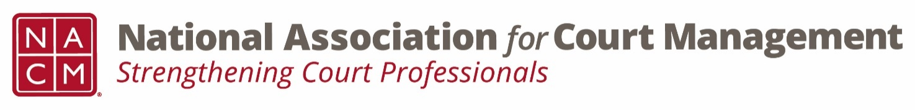

**BOARD CONFERENCE CALL**

**Board Page:** <https://nacmnet.org/board.html>

**Tuesday, June 5, 2018, 2:00 – 4:00 pm ET**

**(800) 503-2899 – Access Code: 2591537**

**AGENDA**

**2:00 President’s Report (40 mins.)** *Vicky Carlson*

1. Approval of Minutes from April 3 Conference Call (<https://nationalcenterforstatecourts.box.com/s/gyaavij1555arvpuxxhq8d5c021zx59v>)
2. President Travel
3. Committee Chair Reports and committee awards at annual conference

**2:40 President-Elect’s Report (5 mins.)** *Paul DeLosh*

1. Conference Development Committee report

**2:45 Vice-President’s Report (5 mins.)** *Will Simmons*

**2:50 Secretary/Treasurer’s Report (5 mins.)** *TJ BeMent*

1. Budget update
2. Education Committee

**2:55 Communications Committee Report (10 mins.)** *Dawn Palermo*

1. Proposal to Establish Webinar Access Policy <https://nationalcenterforstatecourts.box.com/s/qvetrod90bnch82oglvslgq982qsbm89>

**3:05 Governance Committee Report (25 mins.)**  *Greg Lambard*

1. Member Survey (<https://nationalcenterforstatecourts.box.com/s/8qecncalwezxrbn1z9jhx7cifa5s3p9z>)
2. State of the Profession Address

**3:30 Past President’s Report (5 mins.)** *Scott Griffith*

1. Nominations Committee

**3:35 Core Committee (10 mins.)** *Kathy Griffin*

1. Curricula Review
2. Fun Run Shirts

**3:45 NCSC Update (5 mins.)** *Jennifer Haire*

**3:40 New Business/Open Discussion** *All*

**Executive Session (if needed)** *Board*

**Important Upcoming Dates and Events**

* July 1 – Committee Reports for Board Book Due
* July 20 – Officer Meeting at Annual Conference – Atlanta, GA
* July 21 – Board Meeting at Annual Conference – Atlanta, GA
* July 22-26 – Annual Conference