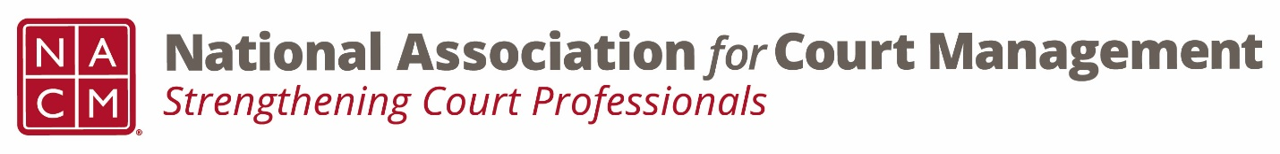
Conference Development Subcommittee
Tuesday, January 18, 2022 – 3:00 PM EST
https://nacmnet.org/committees/standing-committees/education/conference-development-committee/ &
Join from your computer or mobile device:
Zoom Conference Development Subcommittee Meeting
Meeting ID: 710 387 5466
Passcode: 021675
AGENDA
- Welcome
- Midyear Conference 2022 Updates
- Registration #'s
- Hotel Block
- Guest Speakers
- Testing and Masks
- Hosts
- Annual Conference 2022 Updates
- Social event
- Call for Proposals
- Adjourn

Next Meeting: February 15, 2022, 3:00 PM EST

