CONFERENCE DEVELOPMENT COMMITTEE MEETING
Tuesday, April 16, 2019
2:00 PM ET
MINUTES
Welcome and Roll Call.
The Chair reported that the planning for the Annual Conference was going very well largely in part because the RFP process started earlier than normal.
The Chair asked for a vote to approve “special titles/names” for the registration rates due to the conference location. After some discussion the committee approved the following registration rate titles:
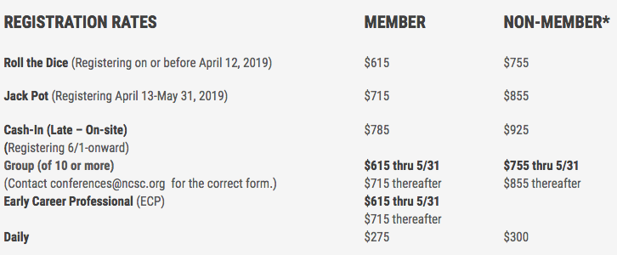

Alyce Roberts &Peter Kiefer provided an update of the live podcast. FaceBook Live will be utilized for live interviews with attendees during the conference. Testing and coordinating is continuing to progress.

TJ Bement, Education Chair provided an update with NACM’s partnership with NASJE. The partnership is a continuation of providing subject matter experts to facilitate a class/presentation to state association leaders and other court managers. Space/registration is limited to 30. TJ also reported that the Education Committee is narrowing down SIGs for the annual conference.

Rick Peirce reported that the State of the Profession is progressing well. The current president of NACM will deliver the address during the Annual Conference.

Kathy Griffin has volunteered her talents to lead two Boot Camp & Yoga/Flow activities for conference attendees. Location will be determined at a later date.

Edwin Bell reported that the hosts for the conference sessions filled quickly. There are members on a wait list should an opportunity presents itself for them to participate. Edwin will also author a Host Responsibilities Guide for volunteers.

Angie VanSchoick shared that Court Appointed Special Advocates (CASA) will be the NACM Cares organization for the annual.

Stacey Smith provided an update on exhibitors.

Next Meeting Date – May 21, 2019, 2:00 pm ET

Meeting Adjourned.

Submitted by Will Simmons

