CONFERENCE DEVELOPMENT COMMITTEE MEETING
Tuesday, March 18, 2019
2:00 PM ET
MINUTES
Welcome and Roll Call

A discussion of the 2019 Midyear Conference in Little Rock, Arkansas was discussed. The theme was “Advancing Todays Courts To Meet the Challenges of Tomorrow”. The committee discussed the post conference survey results and members shared their thoughts and opinions from the conference. Members were provided with the survey results. All remarks were positive. Overall the consensus was that the Mid Year Conference was very successful.

The chairs thanked everyone who participated on the Request for Proposals Subcommittee (RFPS). The Chair further thank Ben Barham, Edwin Bell, Patti Tabias and the NACM Board Members and subcommittee chairs for their role for a success conference.

The Chair begin introduction and theme of the 2019 Annual Conference – July 21-25, 2019 to be held at the Bellagio Hotel in Las Vegas, Nevada.

Theme: Courts and Society: Creating Public
Trust Through Engagement and Innovation

The Annual Conference Page/Agenda was shared and discussed with committee members. The chair and the RFPS had began selecting suggested presenters that submitted proposals. It was noted that the proposals were commendable and applicable to the conference theme.

The conference rates, decided by the NACM Board based upon location, historical data, etc. are:

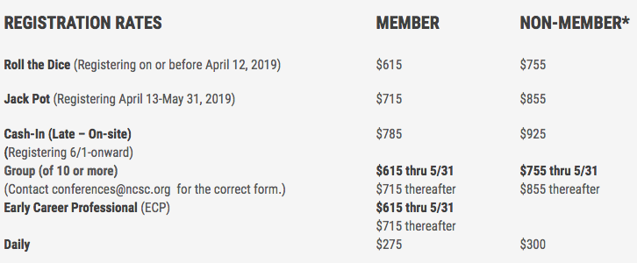

Alyce Roberts, Peter Kiefer & Charleston Carter introduced a new idea to have a Live Podcast/Facebook Live at the Annual Conference. It will feature updates from the conference with interviews of attendees as well as the exciting details of the conference. The idea was well received.

Subcommittees Updates were provided as follows:
Partnership with NASJE – TJ Bement
SIGs – TJ Bement & Alyce Roberts
State of the Profession – Greg Lambard & Rick Peirce
First–time Attendee’s Reception – Alyce Roberts, Linda Romeros-Sole, Elizabeth Stephenson & Rick Pierce
Boot camp & Yoga/Flow – Kathy Griffin
Hosts – Edwin Bell
ECP – Michele Dunivan
NACM Cares - Angie VanSchoick

Stacey Smith and Val Gardner provided the progress of exhibitor registrations, sponsorships and the social event for the annual. It was noted the exhibitors are trending well and several sponsorships are being secured. The social event will be held by the hotel pool. More details will follow.

Jeffrey Tsunekawa updated the committee on the raffle NACM is promoting for the annual. $10 per ticket for a chance to win two tickets to a Las Vegas show, “O”.

Next Meeting Date – April 16, 2019, 2:00 pm ET

Meeting Adjourned.

Submitted by Will Simmons

