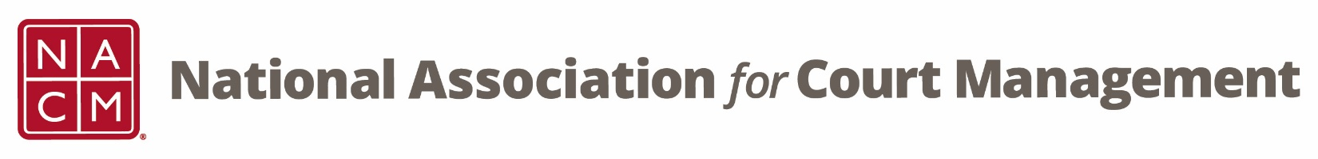

CORE® Committee Meeting
March 23, 2022, 3 p.m. ET
Zoom Core® Subcommittee Meeting
Meeting ID: 870 2190 4254
Passcode: 461646

AGENDA:
- Previous Meeting Minutes – Will be sent out
- 2022 Strategic Priorities - Rick
- CORE Champion Update – Kelly
- Curriculum Review
  - Court Governance
  - Strategic Planning - Kent
- Old/New Business
- Next Meeting: April 27, 2022 at 3 pm ET

