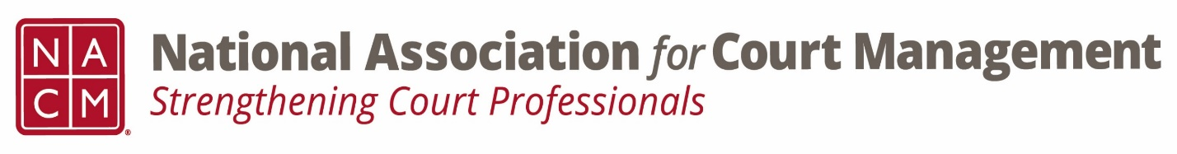
Ethics Subcommittee
Thursday, April 24, 2025
2:00 p.m. Eastern Time
Zoom Link

- Welcome and Introductions of any new participants.
1:07pm
Norman Meyer, Peter Keifer, Courtney Whiteside, Roger Rand, Andrea Powers

- Approval of the Minutes from February 27, 2025.
Approved

- Governance Committee Call Report
  - Court Employee Appreciation Kit
- Committee Reports
  - Conference Development Committee
  - Communications- Social Media & Website
  - DEI
  - CORE- Technology survey going to membership from Roger, updated materials coming- budget and fiscal & caseflow/workflow
  - Membership- ECP, State Associations, & International
  - Past Presidents

- Old Business
  - Review NACM Model Code of Conduct and the NACM AI Guide for February working meeting on Canon 5
      - Model Code of Conduct (Adopted 8/2023)
        - Ethics Subcommittee – National Association for Court Management (nacmnet.org)
      - AI Guide
        - NACM Store – National Association for Court Management (nacmnet.org)

Too broad of a topic to manage in one canon
COC is for personal behavior use, not policy recommendations

2.8  Proper Use of Public Resources | A court professional uses the resources, property, and funds under their official control judiciously and solely in accordance with prescribed procedures.
Comments | Including but not limited to the following.  - Appropriating court funds for personal use.  - Excessive or unauthorized use of court electronic resources.  - Unauthorized use of court issued electronic devices such as laptops, phones, and tablets.  - Unauthorized implementation or use of online services, artificial intelligence products, and social media. (See the most current version of the NACM AI guide for further guidance.)  - Failure to comply with the adopted Information Systems guidelines and policies. For example, using a court email address for personal matters.  - Failure to safeguard court assets from unauthorized access or theft.  - Failure to comply with accepted accounting standards and fiscal directives.

Send out for comment with minute with 2-week deadline for comment
Remove Canon V

- Open discussion/New Business
Search for ethics chair is on

- A Question of Ethics- Suspended
*NOTE* This portion of the meeting will be recorded and shared with the membership.

- Next Meeting- 3/27/2025 @ 2:00pm Eastern Time
AI Guide- Canon 5 working meetings- April, June
May volunteer and topic- Courtney will be at conference and unavailable

