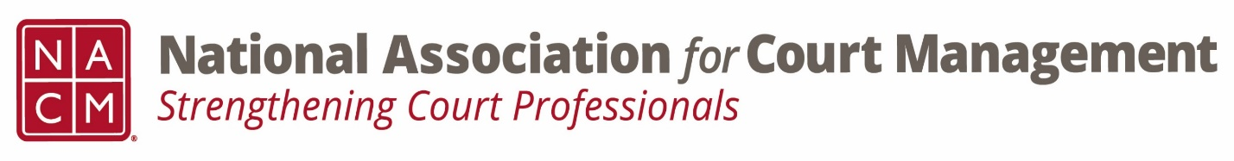
Ethics Subcommittee
Thursday, June 26, 2025
2:00 p.m. Eastern Time
Zoom Link

- Welcome and Introductions of any new participants.

- Approval of the Minutes from April 24, 2025.

- Governance Committee Call Report
  - Voice of the Profession survey
  - State of the Profession address
- Committee Reports
  - Conference Development Committee
  - Communications- Social Media & Website
  - DEI
  - CORE
  - Membership- ECP, State Associations, & International
  - Past Presidents

- Old Business
  - Review NACM Model Code of Conduct and the NACM AI Guide for February working meeting on Canon 5
      - Model Code of Conduct
        - Ethics Subcommittee – National Association for Court Management (nacmnet.org)
      - Any final discussion on removing Canon V
    - Subcommittee chair interest

- Open discussion/New Business
  - Subcommittee chair selection

- A Question of Ethics- Suspended
*NOTE* This portion of the meeting will be recorded and shared with the membership.

- Next Meeting- TBD

