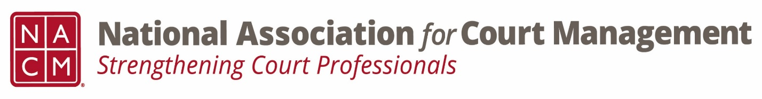
Ethics Subcommittee
Thursday, January 23, 2025
2:00 p.m. Eastern Time
Zoom Link

- Welcome and Introductions of any new participants.
Courtney Whiteside, Norman Meyer, Andrea Powers, Joe Tommasino, Roger Rand, Melinda Brooks, Creadell Webb, Tina Mattison,

- Approval of the Minutes from January 23, 2025.
No corrections. Approved.

- Governance Committee Call Report
  - Original resolution being drafted to honor Mary McQueen
    - Approved by the board
    - Posted on the NACM website for comment

- Committee Reports
  - Conference Development Committee
  - Communications- Social Media & Website
      - Court Manager out next week 3/5, Court Express needs submissions, 1st recorded podcast complete and to Janet to edit
  - DEI
      - DEI session being posted soon.
      - Updates on the evolution and future of DEI
  - CORE-
      - Technology curriculum approved by the board. Subcommittee coming under CORE- not technical in nature but will have JTC involvement- waiting to secure grant funded, goal 2027
      - CORE materials available on website
  - Membership- ECP, State Associations, & International
      - Tribal Court Roundtable- great turn out. Next Federal Court Roundtable- March 27
  - Past Presidents
      - 40th Anniversary plans to memorialize NACM history

- Old Business
  - Review NACM Model Code of Conduct and the NACM AI Guide for February working meeting on Canon 5
      - Model Code of Conduct (Adopted 8/2023)
        - Ethics Subcommittee – National Association for Court Management (nacmnet.org)
      - AI Guide
        - NACM Store – National Association for Court Management (nacmnet.org)

- Open discussion/New Business
  - Canon 5 Discussion Areas:
      - Professional and personal social media and email separate.
      - Unintentional versus Intentional misuse. (Political postings, personal beliefs and information.)
      - Are private settings really private? Is there a presumption of privacy?
      - Relate it back to other canons- impropriety, impugning the dignity of the court. Overarching statement.
      - Title change needed
      - Send out Norman’s article 2011 Court Manager- NCSC if needed.
      - Representative of the judiciary.
      - The ABA has Rule 1.1 (Competence) that we could potentially adapt for our use: Maintaining Competence. To maintain the requisite knowledge and skill, a lawyer should keep abreast of changes in the law and its practice, including the benefits and risks associated with relevant technology, engage in continuing study and education and comply with all continuing legal education requirements to which the lawyer is subject.
      - NCSC AI Policies State Court Guidelines and Policies | NCSC
      - Universal policies- security policies, software updates, etc.
      - CCPIO reach out- Sean O’Sullivan

- A Question of Ethics- Suspended
*NOTE* This portion of the meeting will be recorded and shared with the membership.

- Next Meeting- 3/27/2025 @ 2:00pm Eastern Time
  - AI Guide- Canon 5 working meetings- February, April, June
  - March volunteer and topic needed. Will send out a call for action to the group.

