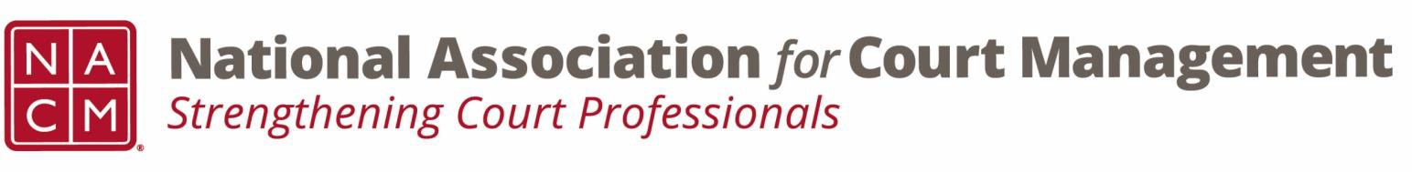

# **Governance Committee Agenda**

**February 5, 2025, 3:00 p.m. Eastern via Zoom**

Zoom link: <https://us06web.zoom.us/j/81227189771?pwd=bRWbW5ruaslCR6VMp5aM1MEXPmXUPP.1>

**Chair:** [Nicole Zoe García](mailto:nicole@nacmnet.org) **Vice Chair**: [Courtney Whiteside](mailto:courtney@nacmnet.org)

[**Committee Page**](https://nacmnet.org/governance-committee/)

1. **Call to Order**
2. **Approval of Minutes**
3. **Reports of Sub-Groups**
   1. Ethics Subcommittee – Courtney Whiteside
   2. Resolutions Subcommittee – Nicole Garcia
4. **New Business**
   1. Formation of Court Employee Appreciation Toolkit Workgroup
      * Introducing Kelsey Leggat
   2. Formation of Association Documents Review Workgroup
      * Introducing Craig Washburn
   3. Formation of State of the Profession Workgroup
5. **NACM Committee Updates**
6. **Adjourn**