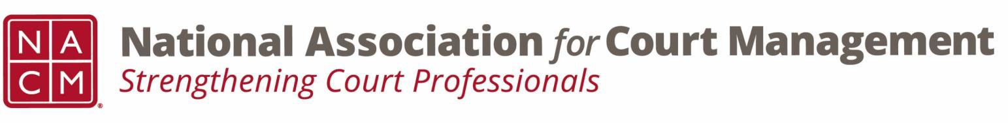

# **Governance Committee Agenda**

**March 5, 2025, 3:00 p.m. Eastern via Zoom**

Zoom link: <https://us06web.zoom.us/j/81227189771?pwd=bRWbW5ruaslCR6VMp5aM1MEXPmXUPP.1>

**Chair:** [Nicole Zoe García](mailto:nicole@nacmnet.org) **Vice Chair**: [Courtney Whiteside](mailto:courtney@nacmnet.org)

[**Committee Page**](https://nacmnet.org/governance-committee/)

1. **Call to Order 1:02**
2. **Approval of Minutes Pete moves Creadell seconded approved**
3. **Reports of Sub-Groups**
   1. Ethics Subcommittee – Courtney Whiteside  
      looking at Canon 5 of model code of conduct, dealing with cyberpresence. Internet, social media, and artificial intelligence. Norman Meyer has provided an outline to work from, group will spend next several meetings fleshing out this complex canon. Question of Ethics from January is out for review, will make the deadline for Spring edition of Court Manager. Looking for a volunteer for March ethics conference call to conduct Question of Ethics recorded conversation.
   2. Resolutions Subcommittee – Nicole Garcia  
      Reso honoring Mary McQueen is in the comment period.
4. **New Business**
   1. Formation of Court Employee Appreciation Toolkit Workgroup
      * Introducing Kelsey Leggat
   2. Formation of Association Documents Review Workgroup
      * Introducing Craig Washburn
   3. Formation of State of the Profession Workgroup  
      Theme is Public Trust and Confidence, SOP should be tied to overarching theme as well as how our profession has evolved over the last 40 years, where have we been and where have we come from. Should be a retrospective and where are we today.
5. **NACM Committee Updates**

Roger – Board has approved the rebirth of the Technology curriculum. This will be the 14th curriculum that will be published, excited to bring this content back to court administration professionals. Looking for financing from SJI. There will be a subcommittee created for this under the CORE subcommittee  
Creadell – continuing to move forward with our efforts, every meeting has a different topic. Membership uses the meeting as an opportunity to share or practice talking about the subject or writing articles. Creadell continues to serve as a resource for DEI. Please share any resources with Creadell so he can share with the group  
Melinda- Court manager will be coming out in the next couple days. Spring deadline is April 8th for publication on June 3rd. Perhaps a summary of the Court Employee Appreciation toolkit? As well as something for Mary McQueen. Natalie is stepping aside as Social Media chair, will be seeking a replacement.  
Roger- website. Document library is in draft status, almost ready for timeline. This will centralize all the documents NACM has. Currently in 3 places – Box, WordPress, Google Docs  
New member page has been greatly improved and will hopefully be ready by Annual. Hired someone who is using AWS to house and organize document, make them searchable.

Separate repository for documents that only Board works on.

1. **Adjourn**