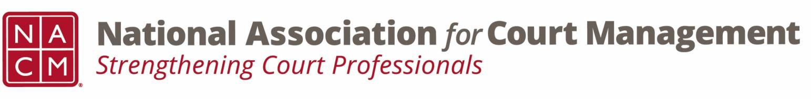

# **Governance Committee Minutes**

**April 2, 2025, 3:00 p.m. Eastern via Zoom**

Zoom link: <https://us06web.zoom.us/j/81227189771?pwd=bRWbW5ruaslCR6VMp5aM1MEXPmXUPP.1>

**Chair:** [Nicole Zoe García](mailto:nicole@nacmnet.org) **Vice Chair**: [Courtney Whiteside](mailto:courtney@nacmnet.org)

[**Committee Page**](https://nacmnet.org/governance-committee/)

1. **Call to Order 3:02pm**
2. **Approval of Minutes Peter moves to approve with correction of title, Creadell seconds**
3. **Reports of Sub-Groups**
   1. Ethics Subcommittee – Pete Kiefer: no meeting for March, continuing to work on Canon 5 dealing with cyber-presence of courts and associated issues that go along with that.
   2. Document Review – Craig Washburn – Reached out to people, Kent shared old spreadsheet that served as a starting point. Craig is reaching out to committee chairs to identify documents, see if they are still used, and where they are located. So far have determined that we can retire some and be at one social media policy instead of three.
   3. Court Employee Appreciation – Kelsey Leggat – Prepared a PDF and Word version with basic components, activities, gestures, press releases, proclamations. Asking her media relations department to look over a potential campaign. Move from outdated public outward communications and instead share via social media. Started drafting an article. Mark W. asks if we will be pairing this campaign with any other campaigns. Yes, Public Servant Appreciation Week, first week of May.
4. **New Business**
   1. State of the Profession Theme and Ideas
      * History of the profession to date
      * What we need for the future of the profession
      * What is needed for the judiciary to maintain public trust and confidence
      * Strengthening the next generation of court leaders
5. **NACM Committee Updates**
   1. Creadell (DEI) – Previous meeting went over AI and how it contributes to bias. Continuing to stay up to date on topics related to DEI and opportunities to participate (write or present).
   2. Kelly (Conference Development) – Registration for Annual is now open, link for draft agenda, awards nominations and scholarships are open. If you want to serve as Social Media, Ethics, or Website chair please reach out to Kelly.
   3. Rick (Past Presidents) – Board nominations, due Friday June 6, award applications. Attended the NCSC board meeting, new president, Beth Clement, was there. Change going on at the center, looking forward to working with Beth.
   4. Tina – met with NCSC on how they can help NACM. NCSC also brought in all the other associations they help with. Really helped Tina and Kelly to have a better understanding of all the other organizations out there. Hoping to cross pollinate and have good collaboration with them. NACM officers voted to give membership to all the organizations present.
6. **Adjourn – Kent moves, Creadell seconds 3:27pm**