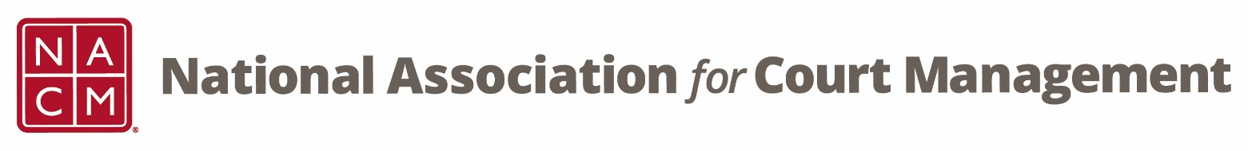

**Conference Development Committee Meeting**

Tuesday, June 16, 2025 at 3 pm EST

[Zoom Link](https://us06web.zoom.us/j/7103875466?pwd=RUplcUdyT0IreEdKalhCNWFiQTgwdz09)

Meeting ID: 710 387 5466

Meeting Passcode: 021675

**Agenda:**

1. **Welcome and Introductions**
2. **Previous Meeting Minutes**
3. **Annual Conference Overview and Updates**
4. **Subcommittees**
   1. **Leadership Seminar – Greg Lambard**
   2. **Hosts – Roger Rand and Kristie Collier**
   3. **Virtual Attendees & MC – Erica Payne Santiago and Cheryl Stone**
   4. **40th Anniversary History – Jude Del Preore**
   5. **Conference Awards and Conference Scholarships – Rick Pierce**
   6. **Fun Run – Jeffrey Tsunekawa and Jeff Chapple**
   7. **Early Career Professionals Fundraiser – Erika Schmidt**
5. **NACM Committee Updates**

**Next Meeting dates**

TBD