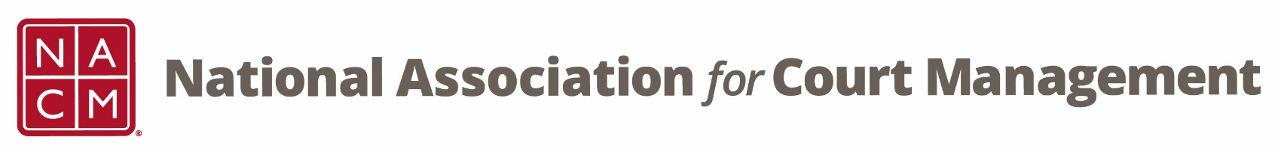

**Conference Development Committee Meeting**

Tuesday, March 18, 2025 at 3 pm EST

[Zoom Link](https://us06web.zoom.us/j/7103875466?pwd=RUplcUdyT0IreEdKalhCNWFiQTgwdz09)

Meeting ID: 710 387 5466

Meeting Passcode: 021675

**Agenda:**

1. **Welcome and Introductions**
2. **Previous Meeting Minutes**
3. **Midyear Conference Overview**
4. **Annual Conference Status/Updates**
   1. **Speaker Notification**
   2. **Agenda**
      1. **Opening Remarks**
         1. **Chief Justice Jeffrey Funke**
      2. **Opening Plenary & Follow-Up**
         1. **Greg Gray – Desperately Seeking Service**
      3. **Business Meeting Remarks** 
         1. **Deputy State Court Administrator Amy Prenda**
      4. **Super Sessions**
         1. **Caroline Nobo – The Science of Trust and Legitimacy**
         2. **Emily LaGratta/Makinta Holloway – Designing a Better Trust Building Playbook**
      5. **Social Event**
         1. **Steelhouse**
         2. **Mixed Nuts**
      6. **State of the Profession – Governance Committee**
      7. **Closing Plenary**
         1. **Andrew Hollingsworth – The Compassion Advantage**
5. **Subcommittees/Tasks**
   1. **Leadership Seminar – Greg Lambard**
   2. **Hosts – Roger Rand and Kristie Collier**
   3. **Virtual Attendees & MC – Erica Payne Santiago?**
   4. **40th Anniversary History – Jude Del Preore**
   5. **Conference Awards and Conference Scholarships – Rick Pierce**
   6. **Fun Run – Volunteer???**
   7. **Early Career Professionals Fundraiser – Erika Schmidt/Katie Hempill**
6. **NACM Committee Updates**
   1. **Board Nominations**

**2024-25 Meeting dates**

April 15, May 20, June 17